**Core java Assignment 1**

**1.**

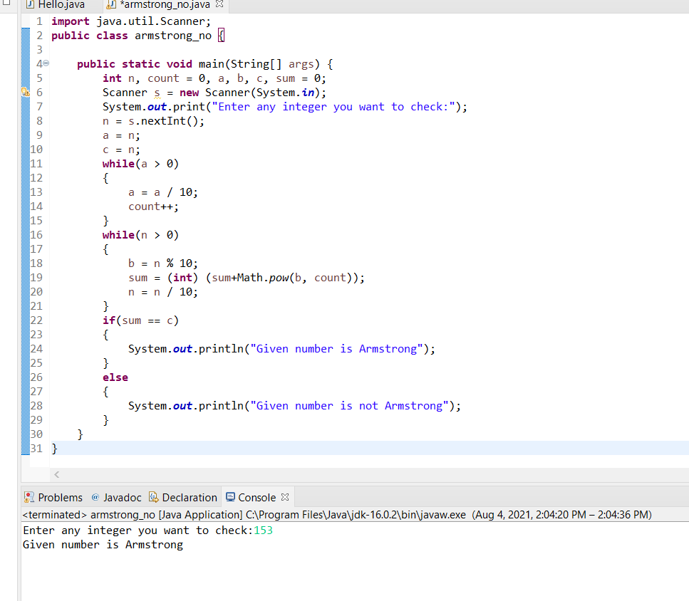

**2.**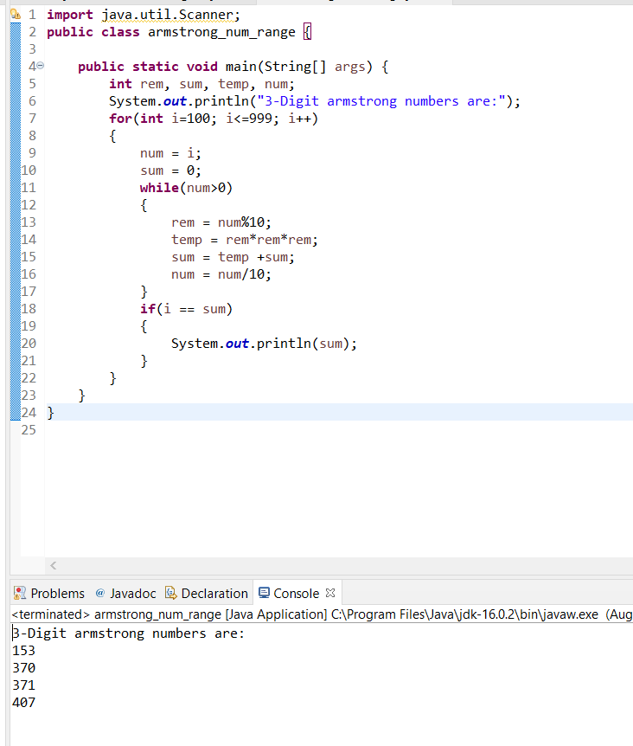

**3.**

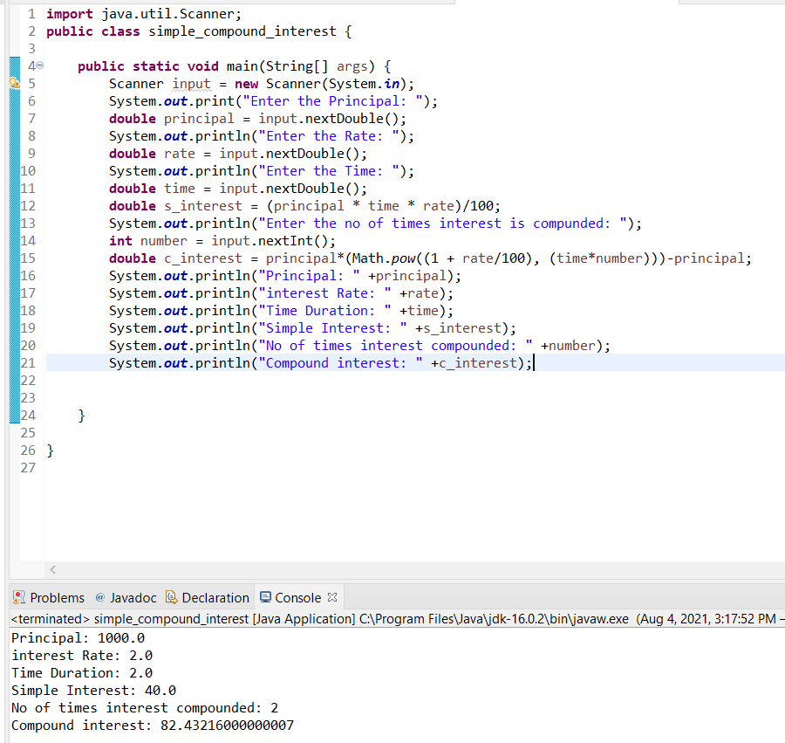

**4.**

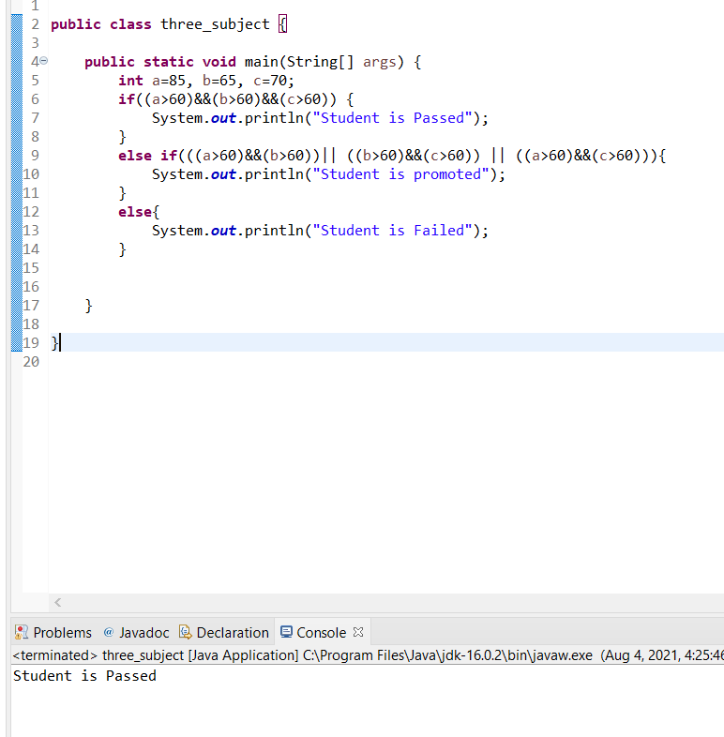

**5.** 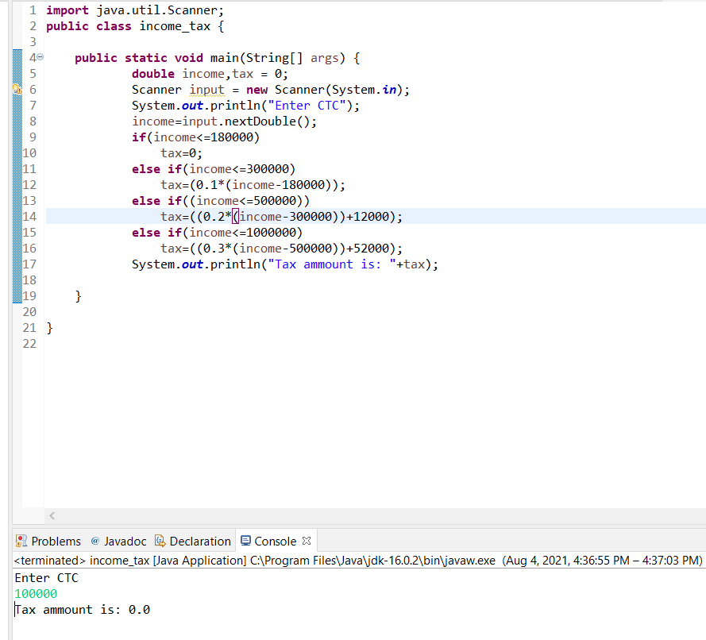

**6.**

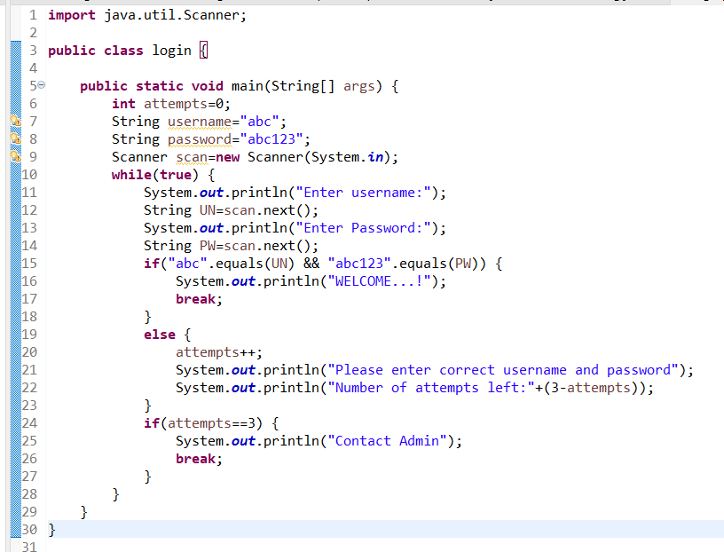

**Output:**

Enter username:

chetana

Enter Password:

123

Please enter correct username and password

Number of attempts left:2

Enter username:

chetana

Enter Password:

563

Please enter correct username and password

Number of attempts left:1

Enter username:

chetana

Enter Password:

789

Please enter correct username and password

Number of attempts left:0

Contact Admin

**7.**

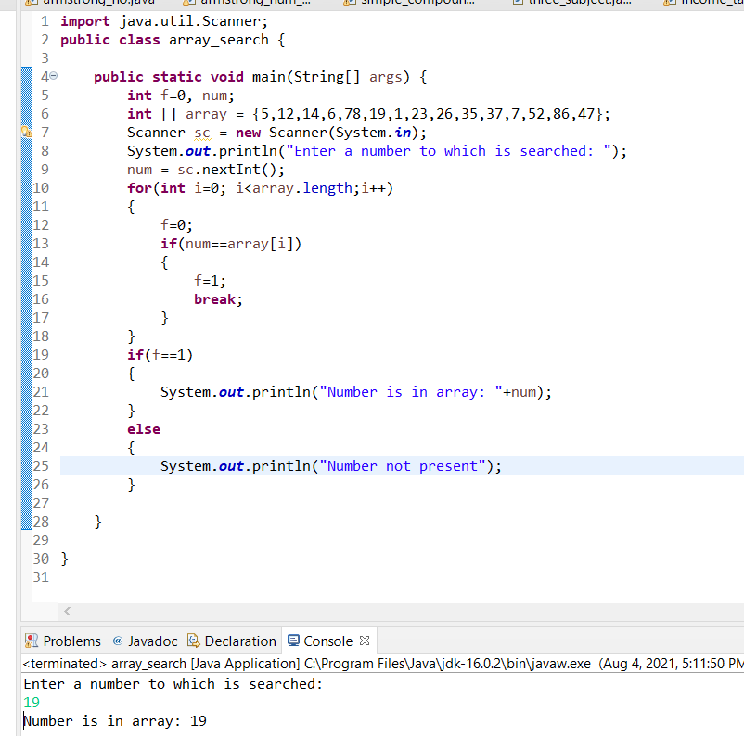

**8.**

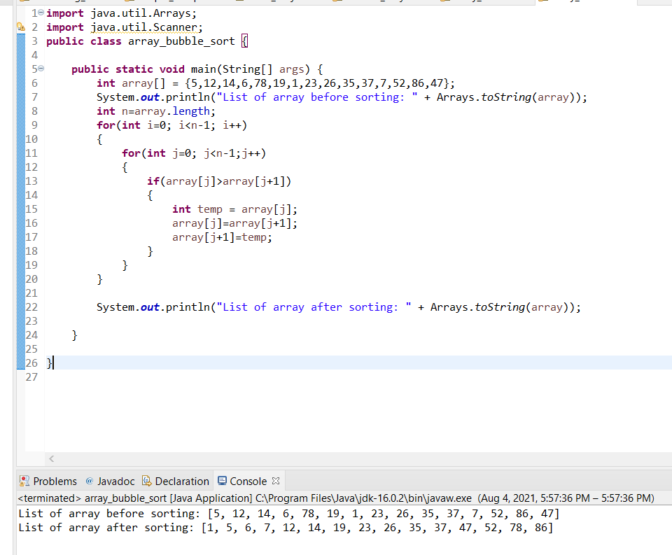

**9.**

